Charleston Southern University
CSCI 325: Object Oriented Programming
Professor Julie Henderson
October 3, 2026

Labyrinth Game

Team Members | GitHub ID
Axel Dugarte | Lugo007
Cole Owens | Name4CSCI301
Luke Hester | cameraman5853
Tyler Fish | FishyFish42

Abstract

This is going to be a game inspired by the Atari Game, Adventure. In this game, the objective is to be able to go through a maze of various difficulties (first decided by the player). Within the maze, there will be different opportunities to score points, adding extra dimensions of strategy within this game. To make this game immersive and interactive, it will utilize a GUI. This will allow the user to see the maze and be able to navigate easily while problem-solving and strategizing their way through an increasingly complicated labyrinth. Beware, there may be unforeseen twists and turns as you go into the depths of this mind-bending puzzle.

Detailed Description of the Program

User Game Menu: This game will first output menu options for the player to choose the difficulty level (Easy, Medium, Hard). After selecting an option, they can go and start the game.
Game Start: The player will be playing a character who is trying to exit a maze. Their position within the maze will not be revealed and will be randomized. Also, the player will be unable to zoom out (to avoid them being able to see too much of the maze), the view will be at a fixed zoom position.
Player Maneuverers: To navigate through the maze, they will use the wasd keys or the arrow keys on their computer to navigate through the maze, in which the character “moves” along with their keystrokes. Since it is a maze, the player is only permitted to go through the open paths, and the walls will act as a barrier to their character.
Maze Design: A Hilbert Lookahead-Curve algorithm will be used to randomly generate the layout of the maze. This makes every single game unique so one can never memorize the layout of the maze from one game to another.
Graphics: Both the character and the walls of the maze will be output. As the person navigates through the maze, they can simply look at the screen and strategically attempt to solve the maze successfully.

Interface: We will use JFrame from the javax.swing libraries. The player will be situated in the center of the screen and will walk around the maze.

Project Division of Labor:

Tyler: In charge of the implementing graphics and making sure everything outputs correctly. (Technical Director)
Axel: Player actions, and character control actions. (The Vigilante Programmer)
Luke: Graphic and Design (Creative Director)
Cole: In charge of making and designing the mazes (Maze Master)

Detailed Division of Labor + Class Descriptions:
Name Responsible | Class/Folder Name | Basic Description
Fish | Main | Contains main(). Sets up GUI and Panel Object.
Fish | Panel | Extends "javax.swing.JPanel". Will house the gameloop thread (tells the game how often to calculate a frame) and handles how the game is displayed on the screen.
Axel | KeyHandler | Handles and interprets user inputs. Getter methods are used to pull the Boolean values of which keys are being pressed.
Axel | Player | Defines how the player moves using the KeyHandler object passed into its constructor, stores positional information, defines player hitbox, and other character specific info,  Has Panel and KeyHandler passed into its constructor.
Fish | Tile | Provides the framework of how each tile of the map is displayed and functions (Should only be about 3-5 lines of code)
Fish | TileManager | Manages the various tile objects, the single MazeGen object, and uses the various tile sprites in the resource folder. Function will define what the various tile types are and assign them values and sprites from the resource file. It will take a map generated by MazeGen (the txt file) and store it as a 2d ArrayList. It will then use the 2d ArrayList to draw tiles on the screen based on the player's position on the map and whether the value of the ArrayList[i][j] matches a value in the defined tile/tile sprites  Has Panel passed into its constructor
Cole | MazeGen | Generates and returns a random maze using Hilbert Lookahead method. Generates a txt file that is saved in the resources folder.  (The txt file format was chosen so that we could store saved maps without losing the array values if the game closes. Also makes the functions easier to text independantly)  Has Panel passed into its constructor
Luke | Collision | Checks whether any valid entity (Player, walls of the maze) is colliding prevents it.
Luke | ResFolder | Stores all of the 2d sprites used to display the map, the player, and the various other items or map attributes

UML Case Diagram (Completed in Class)
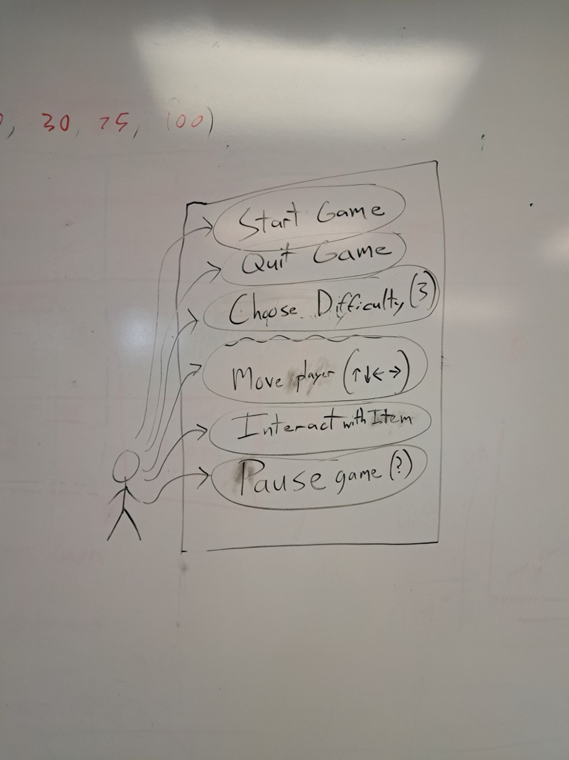

Use Case (Name): | Interact with Item(s)
ID: | 105
Scope: | Play Game, Move Player
Priority: | 7/10
Summary: | This is a general use case dealing with interaction with objects within the maze. It will mainly be used to prevent the player from walking through the walls of the maze
Primary Actor: | The User
Supporting Actors:
Stakeholders: | - The game developers  - Professor Henderson
Generalization:
Include:
Extend:
Precondition: | The game is running and the player is moving the character around
Trigger: | Whenever the character sprite “hits or bumps” against another object in the game. This will be determined by the location in the map.
Normal Flow: | The person is using the WASD or the arrow keys to move the player around the map.
Sub Flows:
Alternate Flow/ Exceptions:
Post-Condition: | The player either completes the maze, or they can pause or quit the game.
Open Issues: | Still in development

Use Case (Name): | Move Player
ID: | 104
Scope: | Start Menu
Priority: | 10/10
Summary: | This is where the user interacts with the game by pressing either the WASD keys or the arrow keys on their computer.
Primary Actor: | The User
Supporting Actors:
Stakeholders: | - The game developers  - Professor Julie Henderson
Generalization:
Include:
Extend:
Precondition: | The player has pushed play game in the game menu
Trigger: | The WASD or arrow keys are pressed
Normal Flow: | The player ‘moves” in the game. The character in the game navigates around the map/maze, which is depicted by the graphics.
Sub Flows:
Alternate Flow/ Exceptions:
Post-Condition: | The player either completes the maze and wins the game, or they decide to quit and exit the game within the middle of gameplay
Open Issues:

Use Case (Name): | Quit Game
ID: | 101
Scope: | Pause Menu
Priority: | 2/10
Summary: | Allows the user to quit the game
Primary Actor: | The User
Supporting Actors:
Stakeholders: | - The game
Generalization:
Include:
Extend:
Precondition: | The Game is currently running and displayed on the screen
Trigger: | The quit button is pressed
Normal Flow: | The game closes
Sub Flows: | A text file containing important game information is saved.  The game object is no longer displayed on the screen and the main menu is displayed again
Alternate Flow/ Exceptions:
Post-Condition: | The game is running
Open Issues:

Use Case (Name): | Start
ID: | 100
Scope: | Main Menu
Priority: | 5/10
Summary: | Allows the player to begin an instance of the game
Primary Actor: | The User
Supporting Actors:
Stakeholders: | - The game
Generalization:
Include: | - Difficulty Level chosen
Extend:
Precondition: | The program is open
Trigger: | The start button is used
Normal Flow: | An instance of the game is created
Sub Flows: | A “game” object is created  It is displayed on the screen until a user decides to quit
Alternate Flow/ Exceptions: | If a game is already in progress, it displays and continues the previously created game object
Post-Condition: | An instance of the game is now running
Open Issues: | Is the game already running?

Use Case (Name): | Pause Game
ID:
Scope: | Within game play
Priority: | 5/10
Summary: | This allows the player to pause the game within gameplay
Primary Actor: | The User
Supporting Actors:
Stakeholders: | - The game creators  - Prof. Julie Henderson
Generalization:
Include: | - Option to resume game  - Option to quit game
Extend:
Precondition: | The game is open and in play
Trigger: | Whenever the escape key is pressed
Normal Flow: | Within the game play, the player clicks the escape key on their computer. This leads them to a screen that gives them the option of either to resume play or to quit the game.
Sub Flows:
Alternate Flow/ Exceptions:
Post-Condition: | An instance of the game is currently running
Open Issues: | Is this game already running?

Use Case (Name): | Choose Difficulty
ID: | 102
Scope: | Main Menu
Priority: | 4/10
Summary: | his use case will be used any time that the  user would like to change the difficulty. The  user can click a button and then select their  desired difficulty from a set list (easy,  medium, hard). The chosen difficulty will  then change how the maze is generated.
Primary Actor: | The user
Supporting Actors:
Stakeholders: | The user: their experience in the maze will depend on their selection
Generalization:
Include:
Extend:
Precondition: | The game is running.  User must be in the main menu.  The game has not started yet.
Trigger: | The user clicks the “Change Difficulty”  button
Normal Flow: | - User clicks the “Change Difficulty” button  - User selects the desired difficulty(easy, medium, hard)  - User returns to the main menu
Sub Flows:
Alternate Flow/ Exceptions:
Post-Condition: | The game is running  User is still in the main menu.  The game has still not started yet.  The difficulty has been changed
Open Issues:

